NEWS | LOCAL

Grand Forks Airport ranked 12th busiest in the country in 2021

Ryan Riesinger, executive director of GFK, said it’s the highest ranking the airport has achieved.
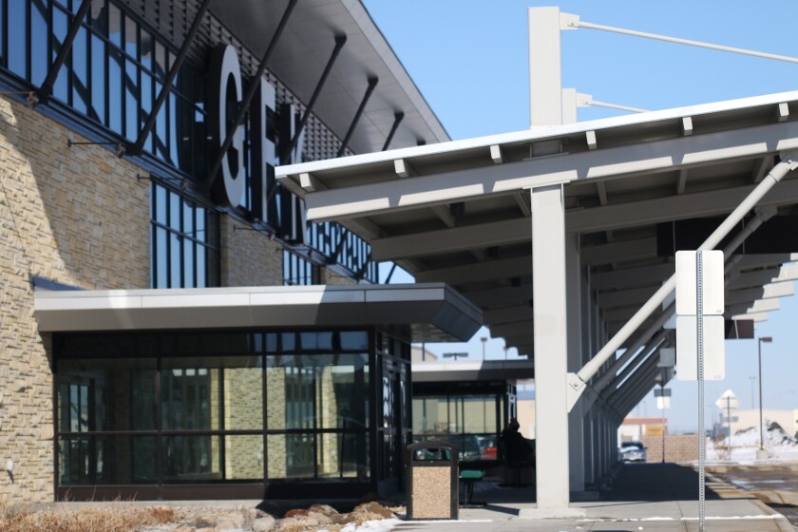
Grand Forks International Airport, as seen in 2021. (Grand Forks Herald photo)
By Adam Kurtz
February 09, 2022 02:42 PM

GRAND FORKS — Grand Forks International Airport has been ranked the 12th busiest in the nation for 2021 in terms of airport operations.
Ryan Riesinger, executive director of GFK, said it’s the highest ranking the airport has achieved. An increased number of flights and operations by UND aviation students drove GFK up the rankings. Those flights were made possible by favorable weather conditions, at least for flying, as well as a higher number of flight instructors at UND and an increase in aviation students.
“It's certainly something that we're proud of,” said Riesinger. “It's a team effort obviously. UND Aerospace does a great job with everything — maintaining 100-plus aircraft and helicopters – and all the great students, instructors and staff.”
Riesinger also noted the efforts of air traffic controllers conducting those flights, and GFK’s ground staff in keeping runways open and safe in setting the new milestone in operations.
According to airport operations data supplied by Riesinger, 349,405 total operations happened at the airport in 2021. Those operations include takeoffs and landings.
Topping GFK at No. 11 on the list is Seattle-Tacoma International Airport, with 374,510 flight operations. Rounding out the top three are:
- Hartsfield-Jackson Atlanta International Airport with 707,661 operations,
- Chicago O'Hare International Airport with 684,201 operations and,
- Dallas-Fort Worth International Airport, with 651,895.
In 2020, Grand Forks airport was ranked 20th in the nation with 246,905 operations, and in 2019 the airport was the 33rd busiest airport. Riesinger said the winter in 2021, marked by warmer temperatures and little snow, allowed students to get in more training flights. Though summer that year was characterized by a lengthy drought, one that disrupted agriculture and saw city water restrictions in Greater Grand Forks, the weather proved to be good for flying, with very few interruptions.
“When you don't have a whole lot of weather, or as many weather disruptions, you can really have a lot more operations,” Riesinger said.
The weather proved to be so conducive for flying that GFK was ranked first in the nation 11 different times in 2021. In March, GFK reached No. one five times, with the highest daily total of operations hitting 2,054. April 27 that year saw operations top 2,200.
And with all that good flying weather came a high number of aviation students. In November 2021, Robert Kraus, dean of the John D. Odegard School of Aerospace Sciences, said the commercial aviation department was operating at capacity, with more than 1,700 students. Those students needed flight instructors, and UND had plenty. With the onset of the pandemic in 2020, commercial airlines curtailed hiring, Riesinger said. That meant UND aerospace graduates took jobs as flight instructors at their alma mater.
While 2021 was a banner year for flight operations, it was marred by one tragedy that saw the death of a UND student. On Oct. 18 John Hauser died on a night flight to Fargo, when his plane crashed into the ground. It was later revealed that Hauser was suffering from mental health issues. His family set up a memorial fund in Hauser’s name, dedicated to mental health in aviation.

